**INTRODUCTION TO ARTIFICIAL INTELLIGENCE**

What is Intelligence?

1. The ability to learn or understand or to deal with new or trying situations
2. The ability to apply knowledge to manipulate one's environment.
3. The ability to comprehend, to understand from experience with the capacity for thought and reason to a high degree
4. The capability of a system to adapt its behavior to meet its goals in a range of environments. It is a property of all purpose-driven decision-makers
5. Other keywords: Creativity, Skill, Consciousness, Emotion and Intuition

**Artificial Intelligence (AI)**

AI aims at emulating human intelligence so as to enable them to act and think like human beings. AI is a combination of several research disciplines, such as computer science, physiology, philosophy, sociology and biology. Conventional AI mostly involves methods now classified as machine learning, characterized by formalism and statistical analysis

According to the father of Artificial Intelligence (AI), John McCarthy, it is *“The science and engineering of making intelligent machines, especially intelligent computer programs”.* AI is a way of making a computer, a computer-controlled robot, or a software think intelligently, in the similar manner the intelligent humans think. AI is one of the newest fields in science and engineering. Work on AI started in earnest soon after World War II, and the name itself was coined in 1956.

Some definitions of AI are organized into four categories as given below:

1. Thinking Humanly: The exciting new effort to make computers think or machines with minds, in the full and literal sense. The automation of] activities that we associate with human thinking, activities such as decision-making, problem solving, learning.

For example, Allen Newell and Herbert Simon, who developed GPS, the “General Problem Solver” (Newell and Simon, 1961), were not content merely to have their program solve problems correctly. They were more concerned with comparing the trace of its reasoning steps to traces of human subjects. COGNITIVE SCIENCE solving the same problems. The interdisciplinary field of cognitive science brings together computer models from AI and experimental techniques from psychology to construct precise and testable theories of the human mind.

1. Thinking Rationally: AI is the study of mental faculties through the use of computational models is called AI. The study of the computations that make it possible to perceive, reason, and act. For example, Logicians in the 19th century developed a precise notation for statements about all kinds of objects in the world and the relations among them.
2. Acting Humanly: The art of creating machines that perform functions that require intelligence when performed by people is known as AI. The study of how to make computers do things at which, at the moment, people are better.

Example: The Turing Test, proposed by Alan Turing (1950), was designed to TURING TEST provide a satisfactory operational definition of intelligence. A computer passes the test if a human interrogator, after posing some written questions, cannot tell whether the written responses come from a person or from a computer. The computer would need to possess the following capabilities.

**Natural language processing** to enable it to communicate successfully in English; **knowledge representation** to store what it knows or hears; **automated reasoning** to use the stored information to answer questions and to draw new conclusions; **machine learning** to adapt to new circumstances and to detect and extrapolate patterns.

1. Acting Rationally: AI is concerned with intelligent behavior in artifacts. An agent is just something that acts. All computer programs do something, but computer agents are expected to do more: operate autonomously, perceive their environment, persist over a prolonged time period, and adapt to change, and create and pursue goals. RATIONAL AGENT change, and create and pursue goals. A rational agent is one that acts so as to achieve the best outcome or, when there is uncertainty, the best expected outcome.

**Applications of AI**

AI has been dominant in various fields such as −

* **Gaming** − AI plays crucial role in strategic games such as chess, poker, tic-tac-toe, etc., where machine can think of large number of possible positions based on heuristic knowledge.
* **Natural Language Processing (NLP)** − It is possible to interact with the computer that understands natural language spoken by humans.
* **Expert Systems** − There are some applications which integrate machine, software, and special information to impart reasoning and advising. They provide explanation and advice to the users.
* **Vision Systems** − these systems understand, interpret, and comprehend visual input on the computer. For example,

For example: A spying aeroplane takes photographs, which are used to figure out spatial information or map of the areas. Doctors use clinical expert system to diagnose the patient. The Police use computer software that can recognize the face of criminal with the stored portrait made by forensic artist.

**Speech Recognition** − Some intelligent systems are capable of hearing and comprehending the language in terms of sentences and their meanings while a human talks to it. It can handle different accents, slang words, noise in the background, change in human’s noise due to cold, etc.

* **Handwriting Recognition** − the handwriting recognition software reads the text written on paper by a pen or on screen by a stylus. It can recognize the shapes of the letters and convert it into editable text.
* **Intelligent Robots** − Robots are able to perform the tasks given by a human. They have sensors to detect physical data from the real world such as light, heat, temperature, movement, sound, bump, and pressure. They have efficient processors, multiple sensors and huge memory, to exhibit intelligence. In addition, they are capable of learning from their mistakes and they can adapt to the new environment.

**Areas of research in AI is as shown below:**

* 1. Neural networks
  2. Robotics
  3. Fuzzy Logic
  4. NLP
  5. Expert Systems

**Real life applications of AI are given as follows:**



Working of Speech and Voice Recognition Systems:

* The user input spoken at a microphone goes to sound card of the system.
* The converter turns the analog signal into equivalent digital signal for the speech processing.
* The database is used to compare the sound patterns to recognize the words.
* Finally, a reverse feedback is given to the database.
* This source-language text becomes input to the Translation Engine, which converts it to the target language text.
* They are supported with interactive GUI, large database of vocabulary, etc.

**Tasks in AI**

The tasks of AI are classified into Formal tasks, mundane tasks, and Expert tasks.

1. **Formal tasks** - are the ones where there is an application of formal logic, some learning etc. Verifications, Theorem proving etc are the common characteristics. Games such as Chess Checkers, Go etc are classified in these task.
2. **Mundane tasks** are the ones that we (the humans) do on regular basis without any special training such as computer vision, speech recognition, Natural language processing, generation and translation etc. Common sense, reasoning and planning are the common characteristics of these tasks.
3. **Expert task** comes under functional expert domain such as engineering, fault finding, manufacturing planning, medical diagnosis etc

Humans learn mundane (ordinary) tasks since their birth. They learn by perception, speaking, using language, and locomotives. Humans learn Formal Tasks and Expert Tasks later, in that order. They learn from past experience. For humans, the mundane tasks are easiest to learn. The same was considered true before trying to implement mundane tasks in machines. Earlier, all work of AI was concentrated in the mundane task domain.

Machine requires more knowledge, complex knowledge representation, and complicated algorithms for handling mundane tasks. This is the reason why AI work is more prospering in the Expert Tasks domain. The expert task domain needs expert knowledge without common sense, easier to represent and handle.

**Major advances in all areas of AI are as follows:**

1. Significant demonstrations in machine learning
2. Case-based reasoning
3. Multi-agent planning
4. Scheduling
5. Data mining, Web Crawler
6. Natural language understanding and translation
7. Vision, Virtual Reality
8. Games

An AI system is composed of an agent and its environment. An agent is anything that can perceive. The agents act in their environment. The environment may contain other agents. To understand the structure of Intelligent Agents, we should be familiar with Architecture and Agent Program. Architecture is the machinery that the agent executes on. It is a device with sensors and actuators, for example: a robotic car, a camera, a PC.

Agent program is an implementation of an agent function. An agent function is a map from the percept sequence (history of all that an agent has perceived till date) to an action.

***Agent = Architecture + Agent Program***

* Architecture = the machinery that an agent executes on.
* Agent Program = an implementation of an agent function.

**Examples of Agents:** A human agent has sensory organs such as eyes, ears, nose, tongue and skin parallel to the sensors, and other organs such as hands, legs, mouth, for effectors. A robotic agent replaces cameras and infrared range finders for the sensors, and various motors and actuators for effectors. A software agent has encoded bit strings as its programs and actions. This is shown the following figure. It has Keystrokes, file contents, received network packages which act as sensors and displays on the screen, files, sent network packets acting as actuators.



Agents are referred with following terminology:

Performance Measure of Agent: It is the criteria, which determines how successful an agent is.

Behavior of Agent: –It is the action that agent performs after any given sequence of percepts.

Percept: It is agent’s perceptual inputs at a given instance.

Percept Sequence: It is the history of all that an agent has perceived till date.

Agent Function: It is a map from the precept sequence to an action

Classification of agents: Agents are classified as follows:

1. Simple Reflex Agents
2. Model-Based Reflex Agents
3. Goal-Based Agents
4. Utility-Based Agents
5. Learning Agent
6. Simple reflex agents ignore the rest of the percept history and act only on the basis of the current percept. Percept history is the history of all that an agent has perceived till date. The agent function is based on the condition-action rule. A condition-action rule is a rule that maps a state i.e, condition to an action. If the condition is true, then the action is taken, else not. This agent function only succeeds when the environment is fully observable. For simple reflex agents operating in partially observable environments, infinite loops are often unavoidable. It may be possible to escape from infinite loops if the agent can randomize its actions.

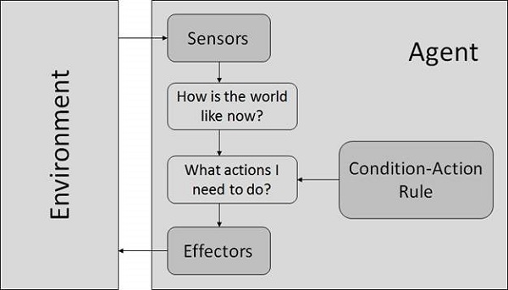

Drawbacks of Simple reflex agents are:

* Very limited intelligence.
* No knowledge of non-perceptual parts of state.
* Usually too big to generate and store.
* If there occurs any change in the environment, then the collection of rules need to be updated.

**Example: An example of this class is a robotic vacuum cleaner that deliberate in an infinite loop, each percept contains a state of a current location [clean] or [dirty] and, accordingly, it decides whether to [suck] or [continue-moving].**

1. Model-Based Reflex Agents: They use a model of the world to choose their actions. They maintain an internal state. Model defines the knowledge about “how the things happen in the world”. Internal State is a representation of unobserved aspects of current state depending on percept history. Updating the state requires the information about how the world evolves and how the agent’s actions affect the world.

**Example of this IA class is the self-steering mobile vision, where it's necessary to check the percept history to fully understand how the world is evolving.**

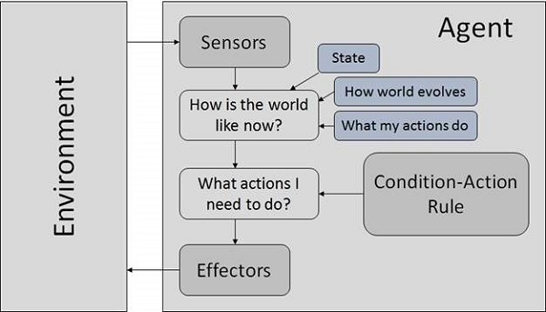

1. Goal Based Agents: They choose their actions in order to achieve goals. Goal-based approach is more flexible than reflex agent since the knowledge supporting a decision is explicitly modeled, thereby allowing for modifications. Here, Goal is the description of desirable situations. **An example of this IA class is any searching robot that has an initial location and wants to reach a destination**

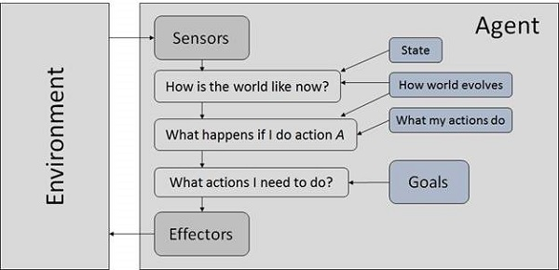

### Utility Based Agents: They choose actions based on a preference (utility) for each state.

Goals are inadequate when there are conflicting goals, out of which only few can be achieved. Goals have some uncertainty of being achieved and you need to weigh likelihood of success against the importance of a goal. The agents which are developed having their end uses as building blocks are called utility based agents. When there are multiple possible alternatives, then to decide which one is best, utility-based agents are used. They choose actions based on a **preference (utility)** for each state. Sometimes achieving the desired goal is not enough. We may look for a quicker, safer, cheaper trip to reach a destination. Agent happiness should be taken into consideration. Utility describes how **“happy”** the agent is. Because of the uncertainty in the world, a utility agent chooses the action that maximizes the expected utility. A utility function maps a state onto a real number which describes the associated degree of happiness.

**Example: An example is the route recommendation system which solves the 'best' route to reach a destination**.

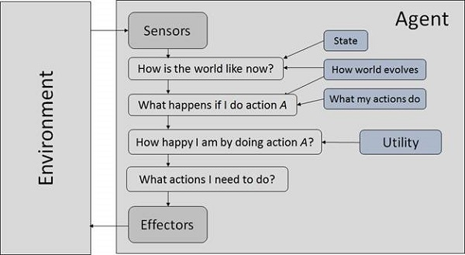

1. **Learning Agent**

A learning agent in AI is the type of agent which can learn from its past experiences or it has learning capabilities. It starts to act with basic knowledge and then able to act and adapt automatically through learning.  
A learning agent has mainly four conceptual components, which are:

1. **Learning element :**It is responsible for making improvements by learning from the environment
2. **Critic:**Learning element takes feedback from critic which describes how well the agent is doing with respect to a fixed performance standard.
3. **Performance element:** It is responsible for selecting external action
4. **Problem Generator:** This component is responsible for suggesting actions that will lead to new and informative experiences.

**Example: Any agent designed and expected to be successful in an uncertain environment is considered to be learning agent.**

**Popular Examples of agents in AI: AI assistants, like Alexa and Siri, are examples of intelligent agents as they use sensors to perceive a request made by the user and the automatically collect data from the internet without the user's help. They can be used to gather information about its perceived environment such as weather and time**

## The Nature of Environments

Some programs operate in the entirely **artificial environment** confined to keyboard input, database, computer file systems and character output on a screen.

In contrast, some software agents (software robots or softbots) exist in rich, unlimited softbots domains. The simulator has a **very detailed, complex environment**. The software agent needs to choose from a long array of actions in real time. A softbot designed to scan the online preferences of the customer and show interesting items to the customer works in the **real** as well as an **artificial** environment.

The most famous **artificial environment** is the **Turing Test environment**, in which one real and other artificial agents are tested on equal ground. This is a very challenging environment as it is highly difficult for a software agent to perform as well as a human.

Turing Test

The success of an intelligent behavior of a system can be measured with Turing Test.

Two persons and a machine to be evaluated participate in the test. Out of the two persons, one plays the role of the tester. Each of them sits in different rooms. The tester is unaware of who is machine and who is a human. He interrogates the questions by typing and sending them to both intelligences, to which he receives typed responses.

This test aims at fooling the tester. If the tester fails to determine machine’s response from the human response, then the machine is said to be intelligent.

Properties of Environment

The environment has multifold properties −

* **Discrete / Continuous** − If there are a limited number of distinct, clearly defined, states of the environment, the environment is discrete (For example, chess); otherwise it is continuous (For example, driving).
* **Observable / Partially Observable** − If it is possible to determine the complete state of the environment at each time point from the percepts it is observable; otherwise it is only partially observable.
* **Static / Dynamic** − If the environment does not change while an agent is acting, then it is static; otherwise it is dynamic.
* **Single agent / Multiple agents** − The environment may contain other agents which may be of the same or different kind as that of the agent.
* **Accessible / Inaccessible** − If the agent’s sensory apparatus can have access to the complete state of the environment, then the environment is accessible to that agent.
* **Deterministic / Non-deterministic** − If the next state of the environment is completely determined by the current state and the actions of the agent, then the environment is deterministic; otherwise it is non-deterministic.
* **Episodic / Non-episodic** − In an episodic environment, each episode consists of the agent perceiving and then acting. The quality of its action depends just on the episode itself. Subsequent episodes do not depend on the actions in the previous episodes. Episodic environments are much simpler because the agent does not need to think ahead.

**Examples of task environments and their characteristics**

